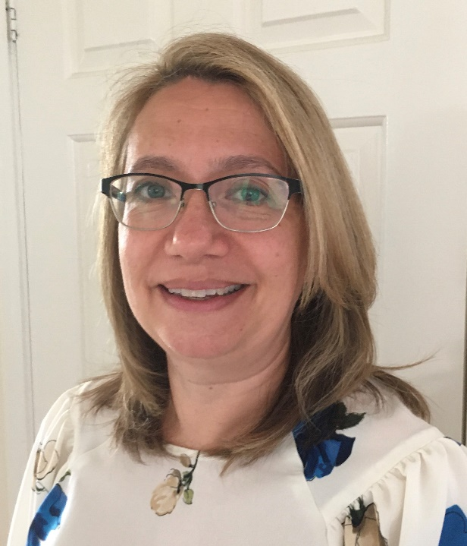

Vanessa Goulding, BSc (Hons), MSc, PGCert Independent Prescribing

Podiatry Professional Lead of the ‘At Risk’ foot for Cardiff and Vale University Health Board (UHB).

Welsh FDUK representative

Vanessa is the podiatry professional lead managing the ‘at risk’ foot provision including the diabetes MDFT for Cardiff and Vale UHB with 28 year's experience of working in the NHS, the last 16 spent specialising in the field of wound care. With an interest in service improvement and innovation she is passionate about improving care by removing barriers to access and supporting opportunities to develop self-management skills for health.

She is a member of the executive committee of the All-Wales Diabetes Foot Operational Delivery Network and FDUK as a welsh representative, supporting work to enable equitable and evidence-based practice is embedded across Wales.

She is committed to supporting the development of healthcare professionals through her roles as honorary tutor for Cardiff University and external lecturer for the University of Southeast Norway, delivering masters modules in the prevention and management of diabetes related foot problems.

She enjoys participating in research and has published several articles in peer reviewed journals.